
SPL-1 Project Report, 2019

A web scraping and parsing Library

SE 305: Software Project Lab 1

Submitted by

Rabiul Islam
BSSE Roll No. : 1012
BSSE Session: 2017-18

Supervised by

Kishan Kumar Ganguly

Designation: Lecturer
Institute of Information Technology

Institute of Information Technology

University of Dhaka

[29-05-2019]

Table of Contents

1. Introduction 3

1.1. Background Study 3

1.2. Challenges 3

2. Project Overview 4

3. User Manual 8

4. Conclusion 11

5. Appendix 11

References 11

- Introduction

The Project is mainly a web scraping and parsing library for pulling data out of html files. It will work with programmer’s parser to provide idomatic ways of navigating and searching through the parse tree. It will extract different type of data from websites such as text, links, heading, title, image, video etc. Beautifulsoup, scrapy, puppeter are examples of this type of library which are implemented in various languages. But this library will be implemented in the c language.

1.1 Background Study

Socket Programming
To get a html file from webpage with a socket in windows operating system, follow the steps below:
- Initialize Winsock
- Create a TCP socket
- Connect to remote server
- Send HTTP GET Request
- Receive a reply from the server

Python Programming, urllib, Beautiful soap
This project has been created by following python’s web scraping. Python’s web scraping was meant to understand the project and to add the feature. In Python we use urllib to get html file and use beautiful soup as a html parser. In this project socket programming has been used to get html file and a html parser tree has been created by following beautiful soup functionality.

1.2 Challenges

Implementing a new software solution carries with it a number of challenges. The process can be overwhelming, confusing and lenthy. For implementing this project there are lot of challenges that I have faced. Some of them are,

- Handling large c code for the first time
- There was a lot of trouble in memory allocation
- Understanding Socket programming on windows in c
- Linked list operations in c

- Project Overview

I have divided my whole project into four different parts. They are
- Get HTML From Webpage.
- Create A Tree By Using HTML File.
- Searching The Tree
- Navigating The Tree

2.1 Get HTML From Webpage

Here, Socket Programming in c Language on windows operating system has been used to get the HTML file from the website. Winsock first needs to be initialized.and then a TCP socket needs to be created.

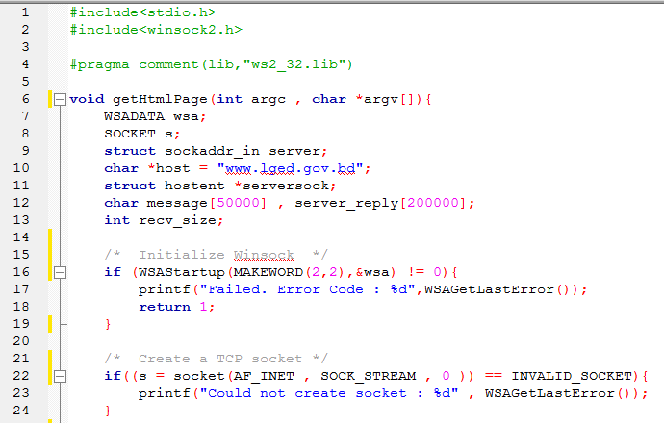

Figure 1: Initilize Winsock and create a TCP socket

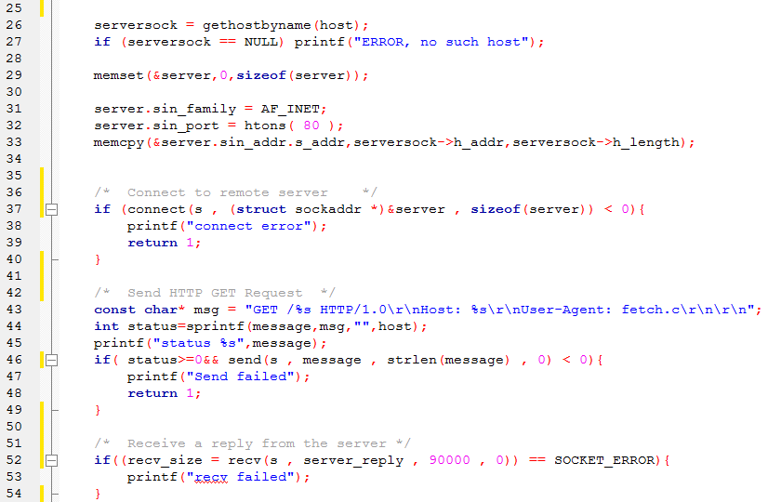

Figure 2: Connect to server, send get request, receive a reply

2.2 Create A Tree By Using HTML File

A tree is built based on tag, attribute and string element of tag. The root of this tree is <html>tag. The Tag can have multiple children. But attribute and String will not have any children. For Example

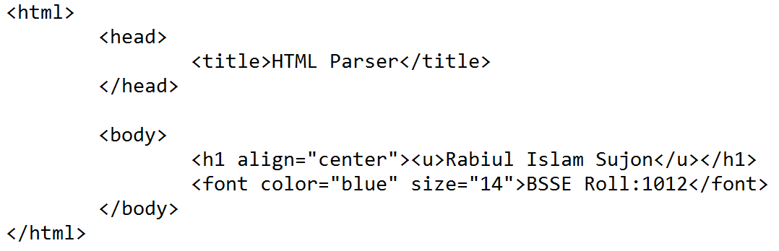

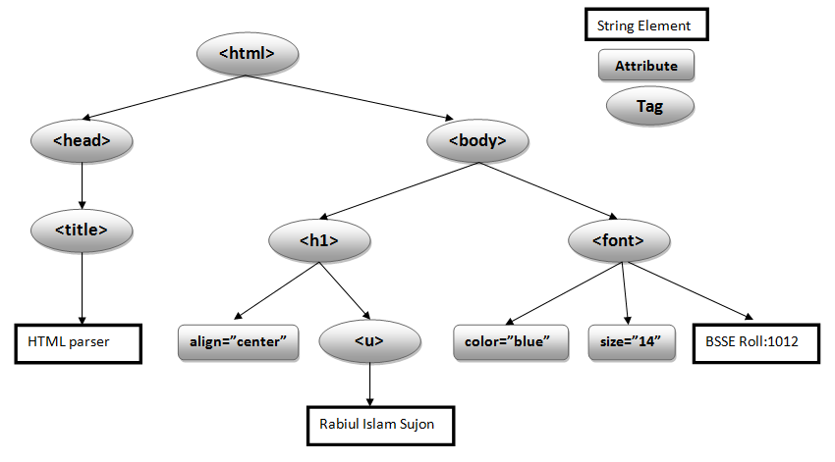Figure 3:HTML parser tree

2.3 Searching The Tree
- char* findAll(root,”[<tag>,attrs,string,re.compile()]”)
The findAll() method looks through a tag's descendants and retrieves all descendants that match our filters.
- findAll(root,”<font>”)
returns collection of the all the <font> associated tag
- findAll(root,”true”)
returns collection of the all tag
- findAll(root,”<font>,color=\’’blue\””)
returns collection of the all the <font> associated tag which have color=”blue” attribute.
- findAll(root,”<font>,color=\”true\”,size=\”14\””)
returns collection of the all the <font> associated tag which have color attribute(any value) and size=”14” attribute.
- findAll(root,”[<font>,<h1>,<img>]”)
returns collection of the all <font> , <h1> , <img> associated tag
- findAll(root,”[<font>,<h1>,<img>],color=\”blue\”,size=true”)
returns collection of the all <font> , <h1> , <img> associated tag and filter by color=”blue” attribute and size attribute(any value).
- findAll(root,id=\”dakatiya\”)
returns collection of the all the tag which id is “dakatiya”.

- findAll(root,”color=\”red\”,face=true,size=\”14\””)
returns collection of the all the tag which color=”red”, have face attribute and size=”14”
- findAll(root,”string=Sujon”)
returns collection of the all the tag which string is Sujon.

- findAll(root,”re.compile(fo)”)
returns collection of the all the tag which tag has substring is “fo”.
- char* find(root,”<tag>,attrs,string,re”)
The only difference is that find_all() returns a list containing the single result, and find() just returns the result.
- findAll(root,”<font>”)
returns a single tag from the <font> associated tag. If there more result, it will return the first one.
- findAll(root,”<font>,color=\”true\”,size=\”14\””)
returns a single tag from the <font> associated tag which have color attribute(any value) and size=”14” attribute.
- findAll(root,”string=Sujon”)
returns a single tag which string is Sujon.

- char* findParent(root,find(<tag>),<to any tag>)
- findParent(root,find(root,”<u>”),<h1>)
if it has parent or grandparent which has <h1> tag then returns full <h1> tag with its element.
- char* findNextSublings(root,<tag>)
- findNextSublings(root,find(root,”<u>”))
returns collection of the all the next siblings of the <u> associated tag.

- char* findPreviousSublings(root,<tag>)
- findPreviousSublings(root,find(root,”<u>”))
returns collection of the all the previous siblings of the <u> associated tag.

2.4 Navigating The Tree

If, soup = find(root,“<tag>”)
allSoup = findAll(root,”[tag]”) then,

- char* getTagName(soup) returns the name of tag from soup.
- char** getAllTagName(allSoup) returns a string array of all the name of tag from allSoup.
- char* getTagString(soup) returns the string of tag from soup.
- char** getAllTagString(allSoup) returns a string array of all the string of tag from allSoup.
- char* getTagChildren(soup) returns the first children of tag from soup.
- char** getTagContents(soup) returns a string array of all the children of tag from soup.
- int numberOfTag(allSoup) returns the number of tag from allSoup.
- int numberOfChildren(soup) returns the number of children from soup.

- User Manual

To get html file and to create a parse tree by the html file we use htmlPerser() function and here we pass webpage address as a string parameter.

struct Node *root = htmlPerser("www.lged.gov.bd") ;

This htmlPerser() will return the root of the parse tree and we have to use this root for searching the tree.

find() and findAll()

INPUT:

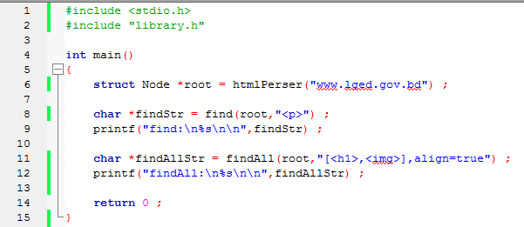

OUTPUT:

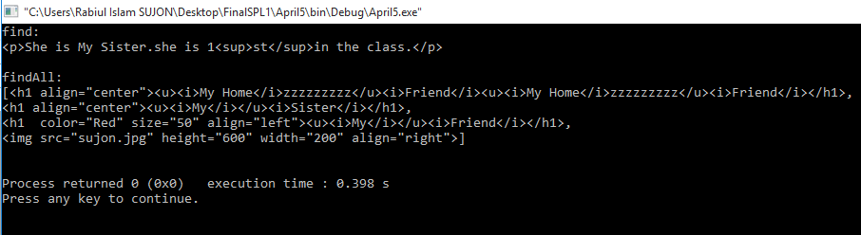

Figure 4,5: Input and output for find(), findAll()

findParent(), findPreviousSublings(), findNextSublings()

Input:

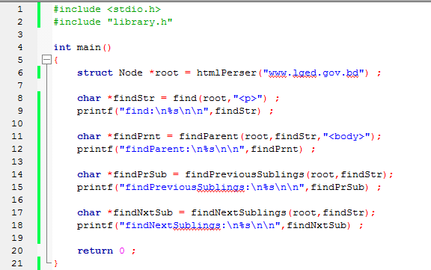

Output:

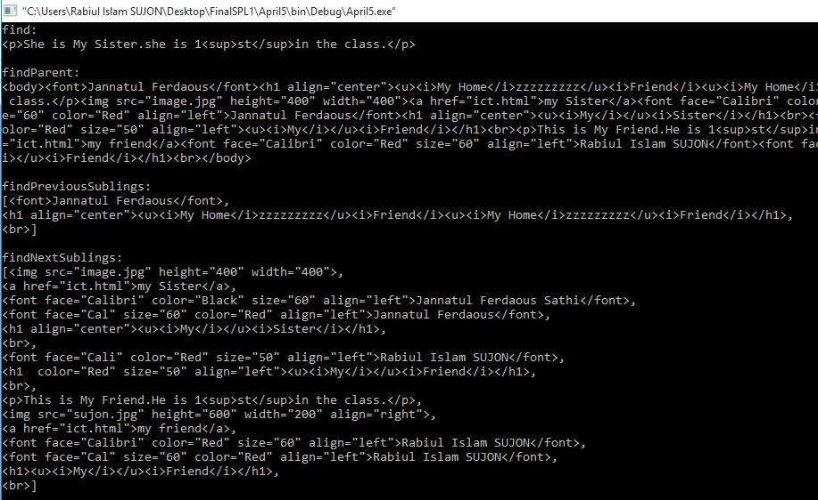

Figure 6,7: Input and output for findParent(), findPreviousSublings(), findNextSublings()

getTagName(), getAllTagName(), geTagContents()

input:

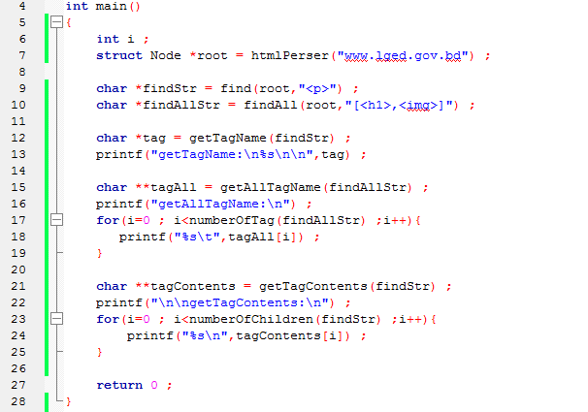

Output:

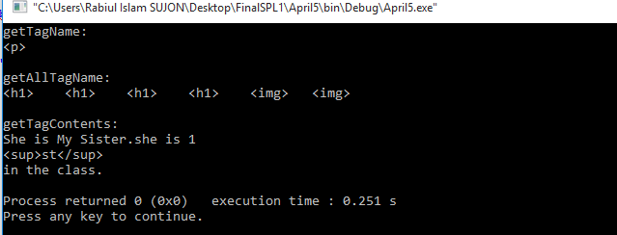

Figure 8,9:Input and output for getTagName(), getAllTagName(), geTagContents()

- Conclusion
The project is mainly based upon web Scraping which are really new topics to me. I had to do some background study in order to do the project. Besides I have handled a large amount of code and besides I have faced a lot of problem and try to solve all this problem so I can learn a lot of new things in c programming. So over all I have made a mark which was suggested to me for this software.

5.Appendix
Beautiful soup is a big html parsing library, so it has many functionality. But we work with some common and important function. In future, I want to add more functionality in this project. And it I experienced hardships while doing this project but still there are few bugs or areas of improvement for me. But overall this is my software.

References

- https://www.crummy.com/software/BeautifulSoup/bs4/doc/
- https://www.binarytides.com/winsock-socket-programming-tutorial/]

